

Assignment no.3

Name: Sukanya Maiti
Roll No. : 59
Dept.: MCA
Subject: C Programming
Submitted To: ANKUR BISWAS

- Write a program to store marks for n number of student in an array and print their marks.
Source Code:
#include <stdio.h>
int main()
{
int n;
printf("Enter the number of students: ");
scanf("%d", &n);
int marks[n];
printf("Enter marks for %d students:\n", n);
for (int i = 0; i < n; i++)
{
printf("Student %d: ", i + 1);
scanf("%d", &marks[i]);
}
printf("\nMarks of all students:\n");
for (int i = 0; i < n; i++)
{
printf("Student %d: %d\n", i + 1, marks[i]);
}
return 0;
}

Input/Output:
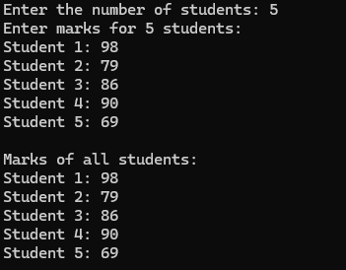

- Write a program that stores the marks of the subject Mathematics and English of n number of students in an array and then prints their total marks.

Source Code:
#include <stdio.h>
int main()
{
int n;
printf("Enter the number of students: ");
scanf("%d", &n);
int mathMarks[n], englishMarks[n];
printf("Enter marks for %d students:\n", n);
for (int i = 0; i < n; i++)
{
printf("Student %d:\n", i + 1);
printf(" Math: ");
scanf("%d", &mathMarks[i]);
printf(" English: ");
scanf("%d", &englishMarks[i]);
}
printf("\nTotal marks for each student:\n");
for (int i = 0; i < n; i++)
{
int totalMarks = mathMarks[i] + englishMarks[i];
printf("Student %d: %d\n", i + 1, totalMarks);
}
return 0;
}

Input/Output:
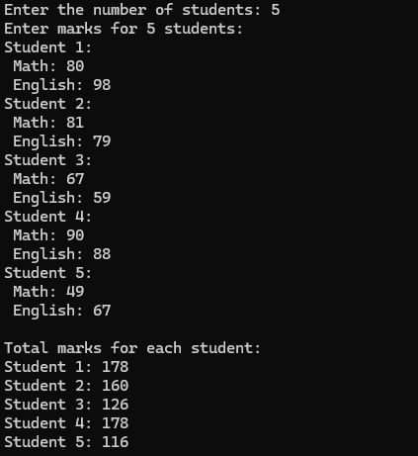
- Write a program to insert an element in an array in a particular position.

Source Code:

#include <stdio.h>
int main()
{
int n, pos, element;
printf("Enter the number of elements in the array: ");
scanf("%d", &n);
int arr[n];
printf("Enter elements of the array:\n");
for (int i = 0; i < n; i++)
{
scanf("%d", &arr[i]);
}
printf("Enter the position where you want to insert the element: ");
scanf("%d", &pos);
if (pos < 1 || pos > n + 1)
{
printf("Invalid position!\n");
return 1;
}
printf("Enter the element to insert: ");
scanf("%d", &element);
for (int i = n - 1; i >= pos - 1; i--)
{
arr[i + 1] = arr[i];
}
arr[pos - 1] = element;
printf("Array after insertion:\n");
for (int i = 0; i <= n; i++)
{
printf("%d ", arr[i]);
}
return 0;
}

Input/Output:
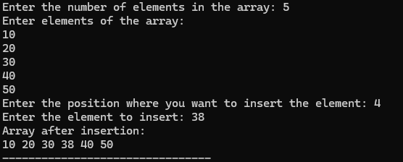

- Write a program to delete an element from a particular position of an array.

Source Code:

#include <stdio.h>
int main()
{
int n, pos;
printf("Enter the number of elements in the array: ");
scanf("%d", &n);
int arr[n];
printf("Enter elements of the array:\n");
for (int i = 0; i < n; i++)
{
scanf("%d", &arr[i]);
}
printf("Enter the position of the element to delete: ");
scanf("%d", &pos);
if (pos < 1 || pos > n)
{
printf("Invalid position!\n");
return 1;
}
for (int i = pos - 1; i < n - 1; i++)
{
arr[i] = arr[i + 1];
}
printf("Array after deletion:\n");
for (int i = 0; i < n - 1; i++)
{
printf("%d ", arr[i]);
}
return 0;
}

Input/Output:
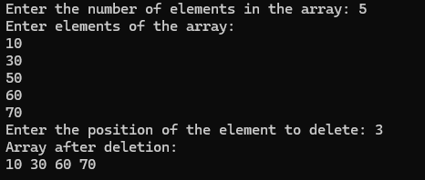

- Write a program to convert a decimal number taken as input from a user to the corresponding binary number and store the result in an array.

Source Code:

#include <stdio.h>
int main()
{
int decimalNum, binaryNum[32], i = 0;
printf("Enter a decimal number: ");
scanf("%d", &decimalNum);
while (decimalNum > 0)
{
binaryNum[i] = decimalNum % 2;
decimalNum /= 2;
i++;
}
for (int j = i - 1; j >= 0; j--)
{
printf("%d", binaryNum[j]);
}
printf("\n");
return 0;
}

Input/Output:
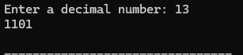

- Write a program to input a binary number in an array and convert it into a corresponding decimal number.

Source Code:

#include <stdio.h>
#include <string.h>
#include <math.h>
int binaryToDecimal(char binary[]);
int main()
{
char binary[32];
int decimal;
printf("Enter a binary number: ");
scanf("%s", binary);
decimal = binaryToDecimal(binary);
printf("The decimal equivalent of %s is: %d\n", binary, decimal);
return 0;
}
int binaryToDecimal(char binary[])
{
int decimal = 0;
int length = strlen(binary);
for (int i = 0; i < length; i++)
{
if (binary[i] == '1')
{
decimal += pow(2, length - i - 1);
}
}
return decimal;
}

Input/Output:
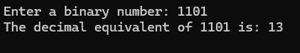

- Write a program to find the smallest and the largest elements in an array.

Source Code:

#include <stdio.h>
int main()
{
int n;
printf("Enter the number of elements in the array: ");
scanf("%d", &n);
int arr[n];
printf("Enter elements of the array:\n");
for (int i = 0; i < n; i++)
{
scanf("%d", &arr[i]);
}
int smallest = arr[0], largest = arr[0];
for (int i = 1; i < n; i++)
{
if (arr[i] < smallest)
{
smallest = arr[i];
}
if (arr[i] > largest)
{
largest = arr[i];
}
}
printf("Smallest element: %d\n", smallest);
printf("Largest element: %d\n", largest);
return 0;
}

Input/Output:
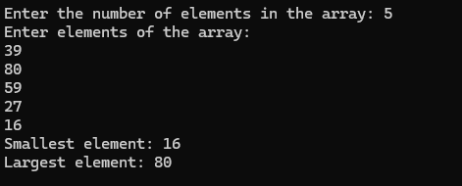

- Write a program for deleting duplicate elements in an array.

Source Code:

#include <stdio.h>
int main()
{
int n;
printf("Enter the number of elements in the array: ");
scanf("%d", &n);
int arr[n];
printf("Enter elements of the array:\n");
for (int i = 0; i < n; i++)
{
scanf("%d", &arr[i]);
}
int uniqueCount = 0;
for (int i = 0; i < n; i++)
{
int isDuplicate = 0;
for (int j = 0; j < i; j++)
{
if (arr[i] == arr[j])
{
isDuplicate = 1;
break;
}
}
if (!isDuplicate)
{
arr[uniqueCount] = arr[i];
uniqueCount++;
}
}
printf("Array without duplicates:\n");
for (int i = 0; i < uniqueCount; i++)
{
printf("%d ", arr[i]);
}
return 0;
}

Input/Output:
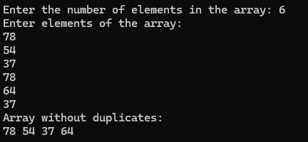
- Write a program to search for a particular element in an array.

Source Code:

#include <stdio.h>
int main()
{
int arr[100], n, search, i, found = 0;
printf("Enter the number of elements in the array: ");
scanf("%d", &n);
printf("Enter %d elements: \n", n);
for (i = 0; i < n; i++)
{
scanf("%d", &arr[i]);
}
printf("Enter the element to search: ");
scanf("%d", &search);
for (i = 0; i < n; i++)
{
if (arr[i] == search)
{
printf("Element %d found at position %d.\n", search, i + 1);
found = 1;
break;
}
}
if (!found)
{
printf("Element %d not found in the array.\n", search);
}
return 0;
}

Input/Output:
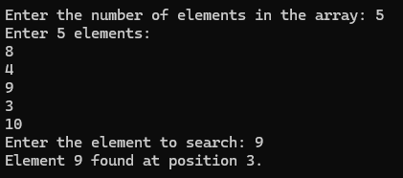

10. Write a program to sort n elements (ascending order).

Source Code:

#include <stdio.h>
int main()
{
int n;
printf("Enter the number of elements in the array: ");
scanf("%d", &n);
int arr[n];
printf("Enter elements of the array:\n");
for (int i = 0; i < n; i++)
{
scanf("%d", &arr[i]);
}
for (int i = 0; i < n - 1; i++)
{
for (int j = 0; j < n - i - 1; j++)
{
if (arr[j] > arr[j + 1])
{
int temp = arr[j];
arr[j] = arr[j + 1];
arr[j + 1] = temp;
}
}
}
printf("Sorted array in ascending order:\n");
for (int i = 0; i < n; i++)
{
printf("%d ", arr[i]);
}
return 0;
}

Input/Output:
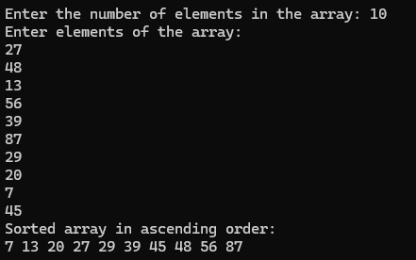

11. Write a program to find second second-highest number from the array without using sorting.

Source Code:

#include <stdio.h>
int main()
{
int n;
printf("Enter the number of elements in the array: ");
scanf("%d", &n);
int arr[n];
printf("Enter elements of the array:\n");
for (int i = 0; i < n; i++)
{
scanf("%d", &arr[i]);
}
int firstHighest = arr[0];
int secondHighest = arr[0];
for (int i = 1; i < n; i++)
{
if (arr[i] > firstHighest)
{
secondHighest = firstHighest;
firstHighest = arr[i];
}
else if (arr[i] > secondHighest && arr[i] != firstHighest)
{
secondHighest = arr[i];
}
}
printf("Second highest element: %d\n", secondHighest);
return 0;
}

Input/Output:
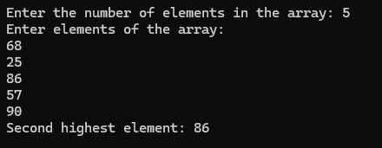

12. Write a program to perform addition and subtraction between two matrices.

Source Code:

#include <stdio.h>
int main()
{
int rows, columns, i, j;
printf("Enter the number of rows and columns of the matrices: ");
scanf("%d %d", &rows, &columns);
int matrix1[rows][columns], matrix2[rows][columns], sum[rows][columns], diff [rows][columns];
printf("Enter elements of the fi rst matrix:\n");
for (i = 0; i < rows; i++)
{
for (j = 0; j < columns; j++)
{
printf("Element [%d][%d]: ", i + 1, j + 1);
scanf("%d", &matrix1[i][j]);
}
}
printf("Enter elements of the second matrix:\n");
for (i = 0; i < rows; i++)
{
for (j = 0; j < columns; j++)
{
printf("Element [%d][%d]: ", i + 1, j + 1);
scanf("%d", &matrix2[i][j]);
}
}
for (i = 0; i < rows; i++)
{
for (j = 0; j < columns; j++)
{
sum[i][j] = matrix1[i][j] + matrix2[i][j];
diff [i][j] = matrix1[i][j] - matrix2[i][j];
}
}
printf("\nSum of the two matrices:\n");
for (i = 0; i < rows; i++)
{
for (j = 0; j < columns; j++)
{
printf("%d\t", sum[i][j]);
}
printf("\n");
}
printf("\nDifference of the two matrices (Matrix1 - Matrix2):\n");
for (i = 0; i < rows; i++)
{
for (j = 0; j < columns; j++)
{
printf("%d\t", diff [i][j]);
}
printf("\n");
}
return 0;
}

Input/Output:
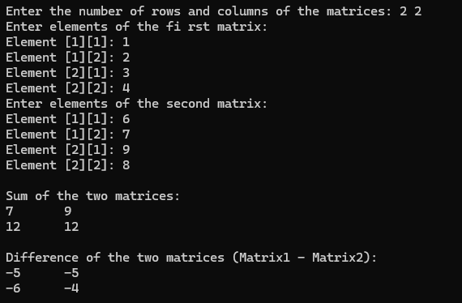

13. Write a program to transpose a matrix.

Source Code:

#include <stdio.h>
int main()
{
int rows, columns, i, j;
printf("Enter the number of rows and columns of the matrix: ");
scanf("%d %d", &rows, &columns);
int matrix[rows][columns], transpose[columns][rows];
printf("Enter elements of the matrix:\n");
for (i = 0; i < rows; i++)
{
for (j = 0; j < columns; j++)
{
printf("Element [%d][%d]: ", i + 1, j + 1);
scanf("%d", &matrix[i][j]);
}
}
for (i = 0; i < rows; i++)
{
for (j = 0; j < columns; j++)
{
transpose[j][i] = matrix[i][j];
}
}
printf("\nOriginal Matrix:\n");
for (i = 0; i < rows; i++)
{
for (j = 0; j < columns; j++)
{
printf("%d\t", matrix[i][j]);
}
printf("\n");
}
printf("\nTranspose of the Matrix:\n");
for (i = 0; i < columns; i++)
{
for (j = 0; j < rows; j++)
{
printf("%d\t", transpose[i][j]);
}
printf("\n");
}
return 0;
}

Input/Output:
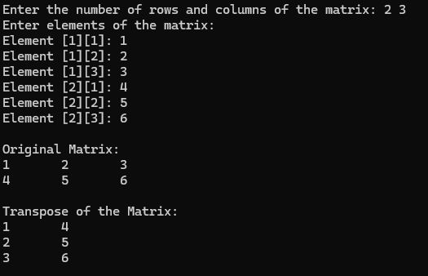

14. Write a program to add the elements of each row and each column of a matrix.

Source Code:

#include <stdio.h>
int main()
{
int rows, columns, i, j;
printf("Enter the number of rows and columns of the matrix: ");
scanf("%d %d", &rows, &columns);
int matrix[rows][columns], rowSum[rows], colSum[columns];
printf("Enter elements of the matrix:\n");
for (i = 0; i < rows; i++)
{
for (j = 0; j < columns; j++)
{
printf("Element [%d][%d]: ", i + 1, j + 1);
scanf("%d", &matrix[i][j]);
}
}
for (i = 0; i < rows; i++)
{
rowSum[i] = 0;
}
for (j = 0; j < columns; j++)
{
colSum[j] = 0;
}
for (i = 0; i < rows; i++)
{
for (j = 0; j < columns; j++)
{
rowSum[i] += matrix[i][j];
colSum[j] += matrix[i][j];
}
}
printf("\nSum of elements in each row:\n");
for (i = 0; i < rows; i++)
{
printf("Row %d: %d\n", i + 1, rowSum[i]);
}
printf("\nSum of elements in each column:\n");
for (j = 0; j < columns; j++)
{
printf("Column %d: %d\n", j + 1, colSum[j]);
}
return 0;
}

Input/Output:
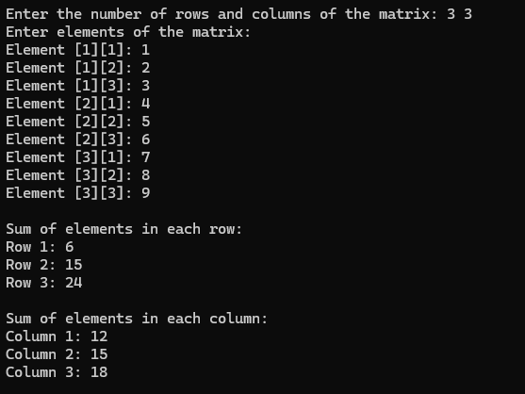

15. Write a program to perform the multiplication of two matrices.

Source Code:

#include <stdio.h>
int main()
{
int rows1, cols1, rows2, cols2, i, j, k;
printf("Enter the number of rows and columns for the first matrix: ");
scanf("%d %d", &rows1, &cols1);
printf("Enter the number of rows and columns for the second matrix: ");
scanf("%d %d", &rows2, &cols2);
if (cols1 != rows2)
{
printf("Matrix multiplication not possible! The number of columns in the first matrix must be equal to the number of rows in the second matrix.\n");
return 0;
}
int matrix1[rows1][cols1], matrix2[rows2][cols2], result[rows1][cols2];
printf("Enter elements of the first matrix:\n");
for (i = 0; i < rows1; i++)
{
for (j = 0; j < cols1; j++)
{
printf("Element [%d][%d]: ", i + 1, j + 1);
scanf("%d", &matrix1[i][j]);
}
}
printf("Enter elements of the second matrix:\n");
for (i = 0; i < rows2; i++)
{
for (j = 0; j < cols2; j++)
{
printf("Element [%d][%d]: ", i + 1, j + 1);
scanf("%d", &matrix2[i][j]);
}
}
for (i = 0; i < rows1; i++)
{
for (j = 0; j < cols2; j++)
{
result[i][j] = 0;
}
}
for (i = 0; i < rows1; i++)
{
for (j = 0; j < cols2; j++)
{
for (k = 0; k < cols1; k++)
{
result[i][j] += matrix1[i][k] * matrix2[k][j];
}
}
}
printf("\nResultant Matrix (Multiplication of Matrix 1 and Matrix 2):\n");
for (i = 0; i < rows1; i++)
{
for (j = 0; j < cols2; j++)
{
printf("%d\t", result[i][j]);
}
printf("\n");
}
return 0;
}

Input/Output:
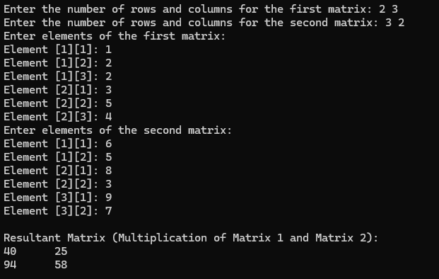

16. Write a program to check whether a matrix is an identity matrix or not.

Source Code:

#include <stdio.h>
int main()
{
int size, i, j, isIdentity = 1;
printf("Enter the size of the matrix (n for an n x n matrix): ");
scanf("%d", &size);
int matrix[size][size];
printf("Enter elements of the matrix:\n");
for (i = 0; i < size; i++)
{
for (j = 0; j < size; j++)
{
printf("Element [%d][%d]: ", i + 1, j + 1);
scanf("%d", &matrix[i][j]);
}
}
for (i = 0; i < size; i++)
{
for (j = 0; j < size; j++)
{
if (i == j)
{
if (matrix[i][j] != 1)
{
isIdentity = 0;
break;
}
}
else
{
if (matrix[i][j] != 0)
{
isIdentity = 0;
break;
}
}
}
if (!isIdentity)
break;
}
if (isIdentity)
{
printf("The matrix is an identity matrix.\n");
}
else
{
printf("The matrix is NOT an identity matrix.\n");
}
return 0;
}

Input/Output:
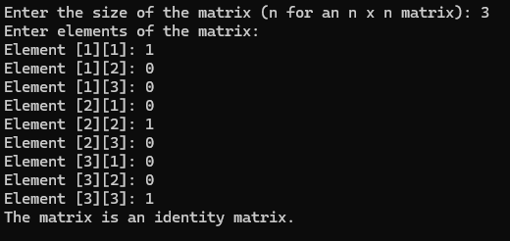

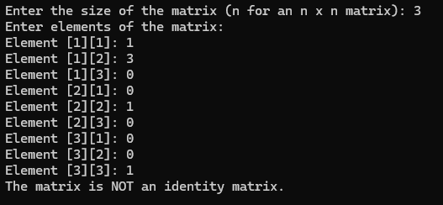

17. Write a program to check whether a matrix is a sparse matrix or not.

Source Code:

#include <stdio.h>
#define MAX_ROWS 100
#define MAX_COLS 100
int main()
{
int rows, cols, count = 0;
int matrix[MAX_ROWS][MAX_COLS];
printf("Enter the number of rows and columns: ");
scanf("%d %d", &rows, &cols);
printf("Enter elements of the matrix:\n");
for (int i = 0; i < rows; i++)
{
for (int j = 0; j < cols; j++)
{
scanf("%d", &matrix[i][j]);
if (matrix[i][j] != 0)
{
count++;
}
}
}
if (count <= (rows * cols) / 2)
{
printf("The matrix is a sparse matrix.\n");
}
else
{
printf("The matrix is NOT a sparse matrix.\n");
}
return 0;
}

Input/Output:
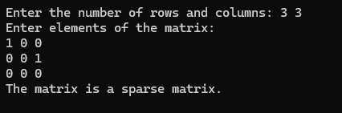

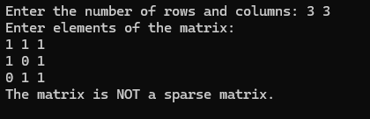

18. Write a C program to create a structure named company which has name, address, phone and no Of Employee as member variables. Read the name of the company, its address, phone and no Of Employee. Finally display these members‟ values.

Source Code:

#include <stdio.h>
#include <string.h>
struct company
{
char name[100];
char address[200];
char phone[20];
int no_of_employees;
};
int main()
{
struct company company_info;
printf("Enter the company name: ");
fgets(company_info.name, 100, stdin);
company_info.name[strcspn(company_info.name, "\n")] = 0;
printf("Enter the company address: ");
fgets(company_info.address, 200, stdin);
company_info.address[strcspn(company_info.address, "\n")] = 0;
printf("Enter the company phone number: ");
fgets(company_info.phone, 20, stdin);
company_info.phone[strcspn(company_info.phone, "\n")] = 0;
printf("Enter the number of employees: ");
scanf("%d", &company_info.no_of_employees);
printf("\nCompany Information:\n");
printf("Name: %s\n", company_info.name);
printf("Address: %s\n", company_info.address);
printf("Phone: %s\n", company_info.phone);
printf("Number of Employees: %d\n", company_info.no_of_employees);
return 0;
}

Input/Output:
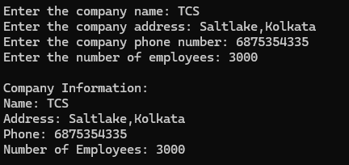

19. Define a structure “complex” (typedef) to read two complex numbers and perform addition, and subtraction of these two complex numbers and display the result.

Source Code:

#include <stdio.h>
typedef struct
{
float real;
float imag;
} complex;
complex add_complex(complex num1, complex num2)
{
complex result;
result.real = num1.real + num2.real;
result.imag = num1.imag + num2.imag;
return result;
}
complex subtract_complex(complex num1, complex num2)
{
complex result;
result.real = num1.real - num2.real;
result.imag = num1.imag - num2.imag;
return result;
}
int main()
{
complex num1, num2, sum, difference;
printf("Enter the real and imaginary parts of the first complex number: ");
scanf("%f %f", &num1.real, &num1.imag);
printf("Enter the real and imaginary parts of the second complex number: ");
scanf("%f %f", &num2.real, &num2.imag);
sum = add_complex(num1, num2);
difference = subtract_complex(num1, num2);
printf("Sum of the complex numbers: %.2f + %.2fi \n", sum.real, sum.imag);
printf("Difference of the complex numbers: %.2f + %.2fi \n", difference.real, difference.imag);
return 0;
}

Input/Output:
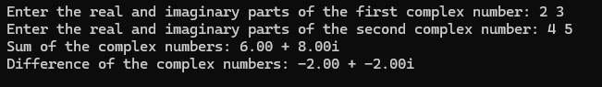

20. Write a C program to read the RollNo, Name, Address, and Age marks of 12 students in the BCT class and display the details from the function.

Source Code:

#include <stdio.h>
#include <string.h>
struct student
{
int rollno;
char name[100];
char address[200];
int age;
float marks;
};
void read_students(struct student students[], int n)
{
for (int i = 0; i < n; i++)
{
printf("Enter details for student %d:\n", i + 1);
printf("Roll No: ");
scanf("%d", &students[i].rollno);
getchar();
printf("Name: ");
fgets(students[i].name, 100, stdin);
students[i].name[strcspn(students[i].name, "\n")] = '\0';
printf("Address: ");
fgets(students[i].address, 200, stdin);
students[i].address[strcspn(students[i].address, "\n")] = '\0';
printf("Age: ");
scanf("%d", &students[i].age);
printf("Marks: ");
scanf("%f", &students[i].marks);
}
}
void display_students(struct student students[], int n)
{
printf("\nStudent Details:\n");
printf("-------------------------------------\n");
printf("Roll No\tName\t\tAddress\t\tAge\tMarks\n");
printf("-------------------------------------\n");
for (int i = 0; i < n; i++)
{
printf("%d\t%-15s\t%-20s\t%d\t%.2f\n", students[i].rollno, students[i].name, students[i].address, students[i].age, students[i].marks);
}
}
int main()
{
int n;
printf("Enter the number of students: ");
scanf("%d", &n);
struct student students[n];
read_students(students, n);
display_students(students, n);
return 0;
}

Input/Output:
